Sri Lanka Institute of Information Technology

Reliability of Twitter

Case Study – Final Report (Draft Copy)
Software Architecture (SE 3030)
Year 03 Semester 01 – 2017

Group ID : DSN-QRL-GR2

Submitted by:
- IT 15068774 - A.P.I.R. Jayathilaka
- IT 14084614 - D.A. Polwattage
- IT 14098888 - S.C.G Liyanage
- IT 14104640 - S.R. Rajapakse
- IT 15029928 - A.M.A.S. Dias

Submitted to:
…………………………..
Mr. Chathura R De Silva
14-05-2017

Executive Summary

Table of Contents

List of Figures

List of Acronyms and Abbreviations

Acronyms / Abbreviations | Meaning
CSI | Crime Scene Investigation
FIFA | Fédération Internationale de Football Association
IBM | International Business Machines Corporation – American multinational technology company
NBA | National Basketball Association
Odeo | Odeo is a digital media company developing tools to support podcasting services.
permalink | A permanent static hyperlink to a particular web page or entry in a blog.
Progressive web app | A term used to denote web apps that uses the latest web technologies.
RSS | A standardized system for the distribution of content from an online publisher to Internet users.  "creating an RSS feed that others can subscribe to"
SXSW | South by Southwest
Yandex | Russian multinational technology company specializing in Internet-related services and products

Introduction

History of Twitter Reliability

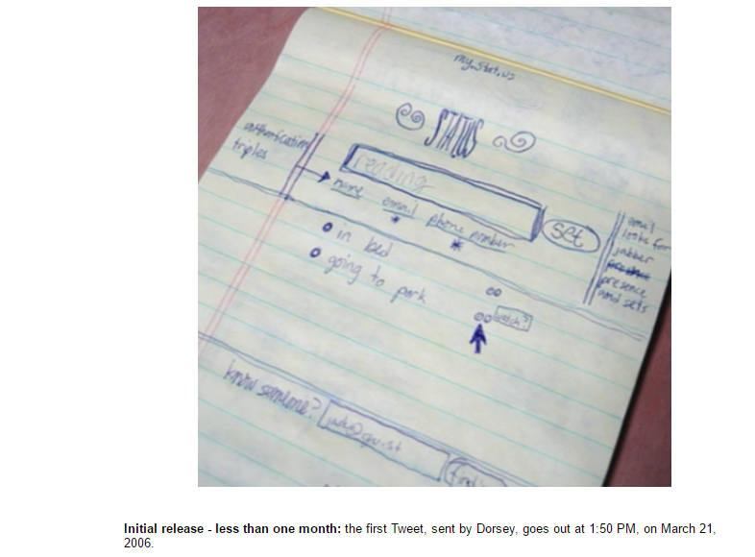
Twitter is an online social media platform where every user can build some reliable opinions. This was created in March of 2006 by Jack Dorsey, Noah Glass, Biz Stone and Evan Williams. ^{[1]} They first created a prototype to simulate their idea which indicates a good feature for creating a quality product.
Figure 1.0:- First Tweet
Figure 1.0 represents the ideation of first Twitter prototype that was used as an internal service for Odeo employees. For using such a service to a company like Odeo there should be a hidden solid background of Twitter. This is initially named as “Twttr” during a period of 2005 to 2006 as in the following image. ^{[2]}

Figure 1.1:- Twttr 2005-2006 prototype

Twttr is founded on February in 2006 and launched as twttr.com to all the private accounts on March 2006 and this was available to public on July 2006. ^{[3]} Therefore we can assume that there was an experimental era for twitter reliability from March to July in that same year. In order to make available Twttr accounts to public definitely there should be high reliable features which everyone can trust. On October 2006, it was rebranded as Twitter.com. ^{[4]}
Figure 1.2:- Twitter 2006–2010
Some people expected Twitter to work with larger ecosystem. As an example in September of 2006, RSS feeds and permalinks of tweets indicated users’ familiarity in blogging ^{[5]} which can be inherited from experience in tweeting. So these facts prove that there’s something believable figure of Twitter from the very beginning of this innovation.

Twitter reached its first tipping point at SXSW conference in March of 2007 while increasing 20,000 daily messages to 60,000 daily messages. ^{[3]} Such a massive 40,000 enhancements for average number of daily messages shows how this was become popular among the users within a short time period. In April of 2007, Twitter got incorporated as a standalone company ^{[3]} which is an example for another milestone of their reliable evolution. This was introduced a mobile site, blocking capability feature and @replies column on May in 2007^{[3]} to expand their functionalities in a smart way. In June of 2007, Dell joined Twitter to corporate for business requirements ^{[3]} where we can predict Twitter was a reliable media even from that period. Your friends on Twitter were defined as followers from July 2007 onwards. And their updates were receiving to you all the time. ^{[3]} This facility would be a better opportunity to measure the reliability of your followers’ tweets. From August of 2007 onwards user could search people based on criteria such as location, name and more which can be called as ‘Twitter profile search goes live’. ^{[3]} Introduction of tracking Twitter alias #Hashtags was happened in September 2007 as a development of earlier tracking feature. ^{[3]} Such inventions might lead Twitter to be appeared in CSI on November in 2007 as a reliable source. Eventually it had 400,000 tweets posted per quarter in 2007. ^{[1]}

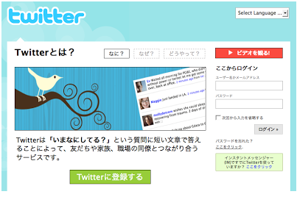
Figure 1.3:- Twitter in Japan
Expanding of Twitter throughout the different countries was basically happened in 2008. In order to make more reliable among Japanese, Twitter launched their first non-English version in Japan on April 2008. ^{[3]}
And in November of 2008, Twitter could get the attraction for reporting the terrorist attacks in Mumbai. ^{[6]} This was played a major role in presidential election of President Barack Obama on November in 2008. ^{[7]} That maybe another reason for him to believe Twitter and became the 3rd top most follower of it. ^{[8]}
Twitter also encountered some reliability downtimes in the history. For an example on January 5 in 2009, due to a dictionary attack Twitter administrator’s password was guessed correctly and 33 high-profile Twitter accounts were compromised with drug related and sexually explicit tweets. ^{[9]} So on June 11 in 2009, Twitter had to launch the beta version of their ‘Verified Accounts’ which was letting famous people to announce their Twitter account name. ^{[9]}

Even though above mentioned kind of things happened twitter was still reliable among the users during that same year in 2009. A school shooting was taken place on March in Winnenden. But students were tweeted the scene of the killings which indicates how much Germans used it normally and how much they were relying on this social media even at the death bed. ^{[5]} And Twitter was the first news supplier in this incident. ^{[10]}
Figure 1.4:- Twitter 2010–2012

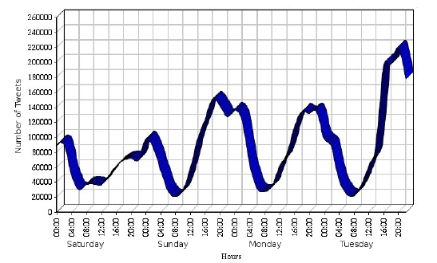
When moving to 2010 earthquake in Chile which occurred on Saturday, February 27, at 03:34:14 local time; Twitter couldn’t be a reliable source. It was started to tweet critical information such as missing people, deceased people, tsunami alerts and other emerging topics in the hours and days after the earthquake. ^{[11]} But there’s a relief to say that all the telecommunications including Internet had intermittent in Chile for the first 48 hours. So we can assume that Twitter users might not use any media often during such an inconsistent period.
Figure 1.5:- Twitter Activities
Other reason for accepting twitter was unreliable in that incident is to discriminate what were the rumours and what were the confirmed news. Even though that was not their software fault that was totally the matter of reliability of tweets, since they were disseminated through twitter also my opinion is Twitter should be responsible there. According to Figure 1.5, tweets were increasing after few days roughly which was not a good sign for reliability of Twitter.
But there were more facts to prove Twitter didn’t get unreliable even in 2010. As examples in FIFA World Cup, 2940 tweets were posted per second in the 30 second period of time and 3085 tweets were tweeted per second in NBA Finals which both of events were happened on June. ^{[9]}
Back in 2011 establishing of some official football club accounts on Twitter was happened. ^{[45]} And launching of Twitter follow button, photo sharing service, link shortening service was occurred in the same year. ^{[3]} Those facts could contribute Twitter to reach its’ 100 million active users logging in at least once a month ^{[14]} while conserving their reliability quality for a long time.
Twitter made a partnership with Russian search engine called Yandex in 2012. Within a short period Yandex could find the value of it because of its real time news feeds. ^{[12]} As below in Figure 1.6, Twitter changed their logo again and still (2017) that is remaining same.

It has reported that 140 million active users and 340 million daily tweets were tweeted by the time of March 2012. ^{[6]} Due to such kind of enhancement of the Twitter reliability, Nielsen and Twitter entered a multi-year agreement in December 2012 to produce social TV ratings which is called as the Nielsen Twitter TV Rating. ^{[14]} It was founded that there were more than 200 million active users with 400 million daily tweets when Twitter reached its seventh birthday. ^{[14]} It was included as one of the top ten most visited websites in the world in 2013. ^{[1]}
Figure 1.6:- Twitter 2012 -present
As reliability downtimes happened in almost all the years, in 2013 also it was revealed that at least 5% accounts on Twitter are fraudulent. The reason behind that was the Twitterbots which is a computer program. It can tweet, retweet and follow other accounts automatically. ^{[1]}
While other companies started cooperating with Twitter, it also commenced to build partnership with others. So in 2014, it was announced a new connection with IBM in order to improve business goals and customer interactions. ^{[1]} We can predict that making a partnership with IBM would be another turning point in their evolution of reliability.
When stepping forward to another year in 2015, Twitter could privilege for another innovative feature called TweetDeck. ^{[12]} It allows people to share team accounts. Interesting part of there is no need to share the passwords among even the group members which could preserve the security aspects. Since it deserves the security, reliability also getting increased with this new function.
In last year, Twitter had more than 319 million active users per month. And also it could prove that it is the largest media for breaking news when 40 million election related tweets were sent on the US presidential election. ^{[1]} So there is no second word of how the reliability had been improved by 2016.
When we come to the current year, it has introduced “Twitter Lite” recently in April 2017. It is a progressive web app which can be used for regions with unreliable internet connections. ^{[1]} Therefore we can confirm that they are still thinking and assure about the reliability of their product Twitter.

Reliability definition by Twitter

Why do people Use Twitter?
People use twitter to learn, and also send and receive messages, News and politics, Sports, pop culture, Influencers and Utility.
People use it for communicate their own ideas and own thoughts to their followers. Companies use twitter for get new ideas to the market and learn about current market.
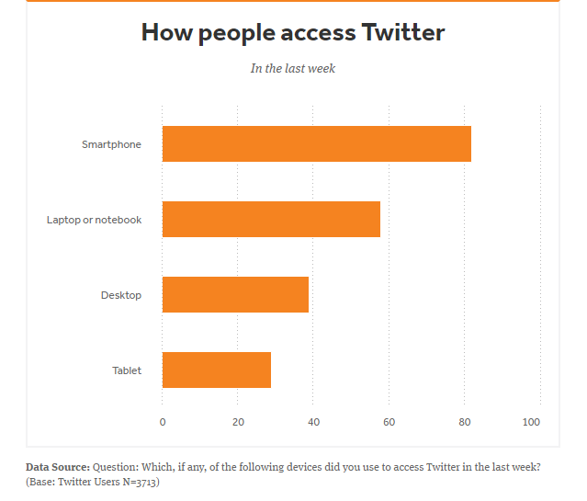
Figure Twitter Definition 0

Twitter allows broadcast posts (tweets) and register members and use twitter in different platforms and devices.
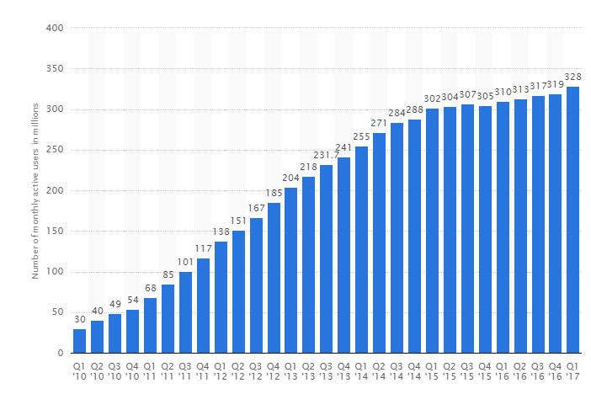
Figure Twitter Definition 1

Reliability Definition
Operations with Free of failures for twitter over a specified time period (Give same result over and over again). When we consider about reliability we consider about these key attributes.
Maturity
At the beginning, Twitter was not grow very fast. But later the no of users increased rapidly. March, 21, 2006 it was founded, since it is more than ten years it is provides conversational ads, Twitter Camera, Twitter Q&A anti-harassment etc.
They developed twitter to adopt the mobile community. There are about five billion sessions per day. The end point interacts with Hundreds of millions of devices every second. There are about 10,000,000 analytics events will receive at the back-end.
Using architectural decisions on decouple components, asynchronous communication and service degradation they make the improvements. To integrate with real time updates, use Lambda Architecture.

Recoverability
Now twitter use Memachache for sorting all the data which is open source, distributed, high performance memory object cashing system. MYSQL use for backup system of the twitter.

Reliability Compliance
According to different requirements twitter change the architecture for best Compliance.
Figure Twitter Definition 2
Availability
When considering availability of twitter mainly focus on,

Fault Tolerance
- Fault avoidance
- Fault detection
- Fault tolerance, recovery and repair
- Programming techniques:
  - Information-hiding, modularity, interfaces
  - Object-oriented techniques
- System structure:
- Simple interactions between components
- Low coupling and high cohesion

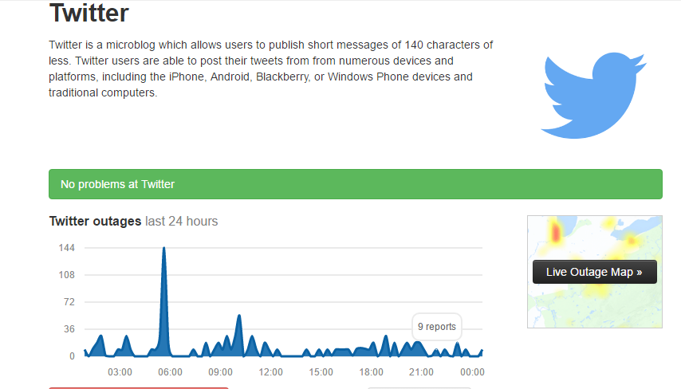
Figure Twitter Definition 3

Accuracy
Boston marathon bombing led accuracy attribute to lowest level and also, there was a false tweet that’s from hacked twitter account that the White House had been bombed and President Obama had been injured. This news affect to the stock market. Therefore, twitter has an accuracy problem.
Predictability
Twitter use their data bases to predict Twitter messages though user’s inputs.

Actions taken for improving reliability

Twitter limits (API, updates, and following)
Limits alleviate some of the strain on the behind-the-scenes part of twitter and reduce downtime and error pages. For the sake of reliability, twitter have placed some limits on the account actions below.
Current twitter limits
The current technical limits for accounts are:
- Direct messages (daily): The limit is 1,000 messages sent per day.
- Tweets: 2,400 per day. The daily update limit is further broken down into smaller limits for semi-hourly intervals. Retweets are counted as Tweets.
- Changes to account email: Four per hour.
- Following (daily): The technical follow limit is 1,000 per day. Please note that this is a technical account limit only, and there are additional rules prohibiting aggressive following behaviour.
- Following (account-based): Once an account is following 5,000 other users, additional follow attempts are limited by account-specific ratios.
These limits include actions from all devices, including web, mobile, phone, API, etc. API requests from all third-party applications are tracked against the hourly API limit. People who use multiple third-party applications with their account will therefore reach the API limit more quickly.
These limits may be temporarily reduced during periods of heavy site usage. In such cases, twitter will post an update on the Twitter Status blog.
src: https://support.twitter.com/articles/15364

Introducing Twitter Lite
Twitter Lite, a Progressive Web App that is available at mobile.twitter.com. Twitter Lite is fast and responsive, uses less data, takes up less storage space, and supports push notifications and offline use in modern browsers. The web is becoming a platform for lightweight apps that can be accessed on-demand, installed without friction, and incrementally updated. Over the last year twitter has adopted new, open web APIs and significantly improved the reliability and user experience.
Hundreds of millions of people visit mobile.twitter.com every month. Twitter wants Twitter Lite to be the best way to use Twitter when users connectivity is slow, unreliable, limited, or expensive. They have been able to achieve speed and reliability through a series of incremental performance improvements known as the PRPL pattern and by using the new capabilities of modern browsers on Android (e.g., Google Chrome).
To reach every person on the planet, twitter needs to reach people on slow and unreliable networks. When available, twitter uses a Service Worker to enable temporary offline browsing and near-instant loading on repeat visits, regardless of the network conditions. The Service Worker caches the HTML application shell and static assets, along with a few popular emoji. And when scripts or data fail to load we provide “Retry” buttons to help users recover from the failure. All together, these changes improve reliability and contribute to significantly faster loading and startup times on repeat visits.
Twitter Lite Architecture overview
Twitter Lite is a client-side javascript application and a small, simple node.js server. The server handles user authentication, constructs the initial state of the app and renders the initial HTML application shell. Once loaded in the browser, the app requests data directly from the Twitter API. The simplicity of this basic architecture has helped us deliver exceptional service reliability and efficiency.
src: https://blog.twitter.com/2017/how-we-built-twitter-lite

The infrastructure behind Twitter
Hardware efficiency
Procuring and consuming hardware at Twitter’s scale comes with a unique set of challenges. In order to meet the demands of internal customers, twitter initially started a program to qualify and ensure the quality of purchased hardware. The team was primarily focused on performance and reliability testing ensuring that systems could meet the demands. Running systematic tests to validate the behaviour was predictable, and there were very few bugs introduced.
As twitter scaled their major workloads (Mesos, Hadoop, Manhattan, and MySQL) it became apparent the available market offerings didn’t quite meet the needs. Off-the-shelf servers come with enterprise features, like raid controllers and hot swap power supplies. These components improve reliability at small scale, but often decrease performance and increase cost; for example, some raid controllers interfered with the performance of SSDs and could be a third of the cost of the system. By stranding CPU cores and disk capacity to meet IOPS requirement, they were able to increase reliability and performance but it wasn’t a cost-effective solution.
Major technology changes and adoption
- 2012 - SSDs become the primary storage media for MySQL and key/value databases.
- 2013 - first custom solution for Hadoop workloads is developed, and becomes primary bulk storage solution.
- 2013 - custom solution is developed for Mesos, TFE, and cache workloads.
- 2014 - custom SSD key/value server completes development.
- 2015 - custom database solution is developed.
- 2016 - they developed GPU systems for inference and training of machine learning models.
src: https://blog.twitter.com/2016/the-infrastructure-behind-twitter-efficiency-and-optimization

Evolution of Architecture

At the beginning of Twitter the back-end service was only a MySQL database that was used to store all the messages that were being posted. Ruby on Rails was used to make the website and the interactions. Also, the front-end service was written in Ruby on Rails and it provided the communication between the back-end service. With this architecture, they could satisfy the users most important software quality aspects, reliability, availability, performance. At that time, nobody had foreseen the immense growth of twitter the following two years, so further improvement of the system was not a priority.

In 2007, Twitter really started to grow more rapidly and this exponential growth continued in 2008. With this growth, the front-end service alone couldn’t handle all the requests. The solution was a middle layer that could handle the enormous amount of Tweets posted per second. This middle layer was also written in Ruby on Rails and provided a queuing system in which the tweets could be saved before they were written to the back-end makes the system more robust. This improved the reliability quality aspect of the system.

Reliability Testing
Twitter strive to prepare for sustained traffic as well as spikes, some of which the can plan for, some of which comes at unexpected times or un unexpected ways. To prepare for those varied types of traffic, they continuously run tests against their infrastructure to ensure it remains a scalable and highly available.

They have created a framework to perform different types of load and stress tests in different stages of a service live cycle in different environments. These tests help them to be more confident that their products are highly available and responsive at all times and under any circumstance. As a part of this reliability testing, the generate distributed multi-datacenter load to analyse the impact and determine the bottlenecks.

Trade-offs in Reliability Quality Aspects of Twitter

A trade-off is a situation in which you decrease one quality aspect in return for increasing another quality aspect. [2] Ideally, software design decisions are made with full understanding of the positive and negative implications on its quality aspects. An example of a trade-off is a highly structured and modularized code that is easy to read by humans, hence easy to maintain. However, because it is highly structured it does not perform as well as less structured code.
In this case, a trade-off between Maintainability and Efficiency is made. An increase in Maintainability will decrease the Efficiency of a system and vice-verse. This situation can be illustrated by the sliders in Figure 4.1.

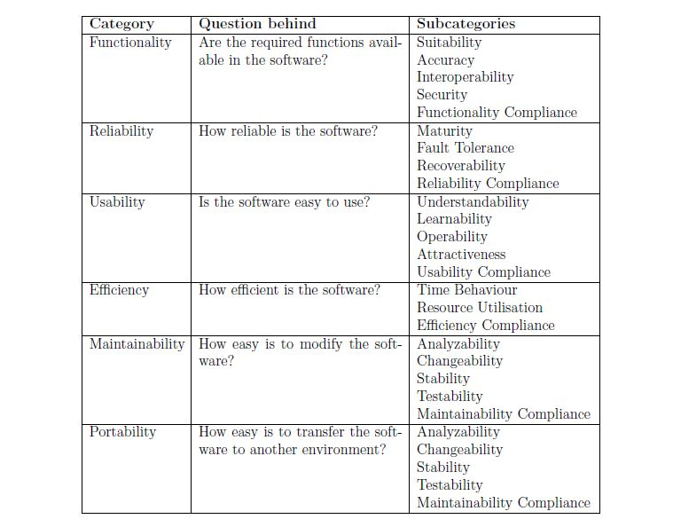
Table 4.1: Categories and Sub-Categories of the ISO 9126 standard
Figure 4.1: The trade-off problem illustrated with sliders
The first slider shows a trade-off in favor of Efficiency, as the slider is set closer to Efficiency than to Maintainability. The second slider shows a trade-off in favor of Maintainability, as the slider is set close to Maintainability than to Efficiency. However, the second slider indicates that a lot of Efficiency is traded off against Maintainability. The first indicates a more neutral trade-off between Efficiency and Maintainability as the slider is positioned relatively close to the center of the bar. [2]

So the question here is “How reliable the twitter is?”,

Trade-off 1: Reliability Versus Maintainability

To improve the reliability, the complexity of Twitter's server-infrastructure increased. They started to use more servers and they all had to be balanced and synchronized. Balancing and synchronizing servers using MySQL databases is not the easiest task, thereby reliability for maintainability. [2]

They implemented a new feature called middle layer which is basically used as a queueing system to not overload the back-end service layer, as was the case before when they used no middle layer and only MySQL for storage. The middle layer was first implemented by Starling which is programmed in Ruby on Rails. But as this turned out to be too slow and with an unsatisfactory crash recovery. Then they used JRuby, RabbitMQ respectively with same false outcome. Finally, they used Scala. But they had to trade-off between maintainability and reliability since another language added to their long list of technologies they use for twitter.
[2]

Until 2012, running a service inside Twitter required hardware requisitions. Service owners had to find out and request the particular model or class of server, worry about your rack diversity, maintain scripts to deploy code, and manage dead hardware. So they migrated from bare metal environment to Mesos/Aurora which provides automatic rescheduling the instance on another host. This increased both maintainability, efficiency and reliability in twitter since generally each service that got their own bare metal hardware didn’t fully utilize its resources and did a poor job of managing capacity. Mesos allowed them to pack multiple services into a box without having to think about it, and adding capacity to a service is only requesting quota, changing one line of a config file, and doing a deploy. [1]

Trade-off 2: Reliability Versus Performance and Cost

As twitter scaled their major workloads (Mesos, Hadoop, Manhattan, and MySQL) it became apparent the available market offerings didn’t quite meet the needs. Off-the-shelf servers come with enterprise features, like raid controllers and hot swap power supplies. These components improve reliability at small scale, but often decrease performance and increase cost; for example, some raid controllers interfered with the performance of SSDs and could be a third of the cost of the system. [1]

Trade-off 3: Reliability Versus Efficiency

Twitter’s workload is divided into four main verticals: storage, compute, database, and gpu. Twitter defines requirements on a per vertical basis, allowing Hardware Engineering to produce a focused feature set for each. This approach allows them to optimize component selection where the equipment may go unused or underutilized. For example, their storage configuration has been designed specifically for Hadoop workloads and was delivered at a TCO reduction of 20% over the original OEM solution. At the same time, the design improved both the performance and reliability of the hardware. Similarly, for their compute vertical, the Hardware Engineering Team has improved the efficiency of these systems by removing unnecessary features. [1]

Compare Twitter Reliability with Facebook Reliability

With the growing popularity of Twitter and Facebook as of late, it is important to question which website is more reliable.
According to an article published by Hend Salah on November 24, 2013 and By Burke Speaker, Investorplace Writer on Nov 25, 2013,
- Facebook has been caught in privacy lawsuits
Facebook has been charged several times with using users’ personal information in advertisements. This means that the people who manage the website see every little detail of their users’ profile information, no matter how “private” someone makes their settings. Pictures, comments and the like can be taken and used for whatever they want, including but not limited to promotion for their website. With Facebook caught in privacy in lawsuits and constantly irking users with changes to its settings, Twitter seems to come out in this area.
- Twitter has created new security efforts
Twitter has launched a new effort to increase security on their website. They have added a new encryption layers to keep third-parties from being able to spy on Twitter accounts. This also means that “phishing” and hacking is increasingly more difficult to do on this social network, keeping passwords safe as well.
- President of Iran uses Twitter
Iran has–for a long time–been almost an enemy to countries like the United States. However, if the president is secure enough to go onto Twitter and give his own opinions without worrying about being spied on, it’s probably safe enough for anyone else.
- Twitter is less personal
Socially, Twitter is not known to be a place to post things certain people shouldn’t see. It’s a website for essentially nothing more than status updates, and these status updates are generally public. Twitter is more promotional than anything else. It’s a place to go to get people to see things that the poster has done or written, or attracts consumers to goods. It isn’t widely used for hiding things. Because Twitter is less personal, it is less likely that hackers will want to go into it and try to find things out. Because less people expect there to be anything worth reading on that social network instead of Facebook.
According to above mentioned two writers, those are the main reasons to prove that Twitter is more reliable than Facebook.
Twitter has the problem which was called as “Fail Whale” that has become annoying familiar to users. Below image will appear when the server is down or over capacity at frequent moments.

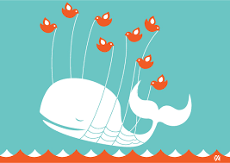
The original Fail Whale, originally titled "Lifting a Dreamer"
According to an article By Victor Luckerson on Nov. 06, 2013 example for the fail whale is,
In 2007, when Twitter first came to prominence at the South by Southwest interactive festival, the social network became notorious for its downtime. Between server overload and scheduled maintenance, the site was offline for almost six days total that year, according to Pingdom, a service that tracks website performance. Things were not much better in 2008, when the site crashed during Steve Jobs’ keynote at MacWorld in January. Co-founder Biz Stone described the site as being in constant “emergency maintenance mode” at the time. By May the quickly growing site had created a standalone blog just to tell users when Twitter was down.

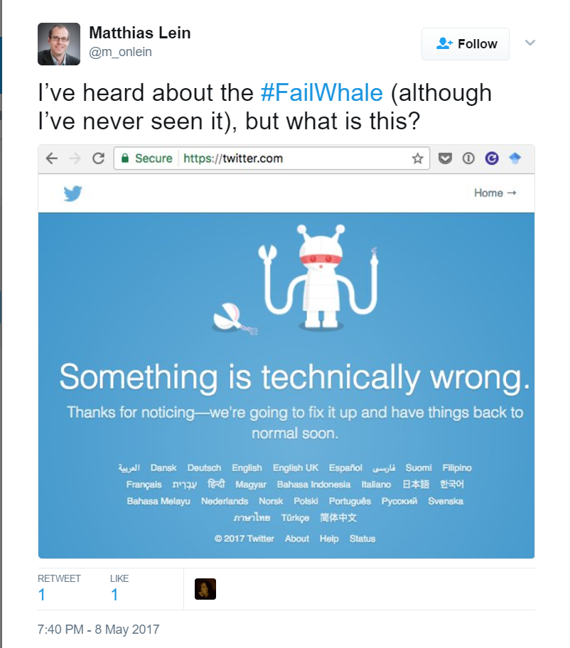
Fail whale problem faced by a twitter user recently (2017)

According to an article published by Leonie Bulman on 26th July 2010,
Twitter has introduced a custom built data centre in 2010 to ambitious enough to fix reliability issues like fail whale but according to experts it hasn’t been a complete success solution to the reliability issues.
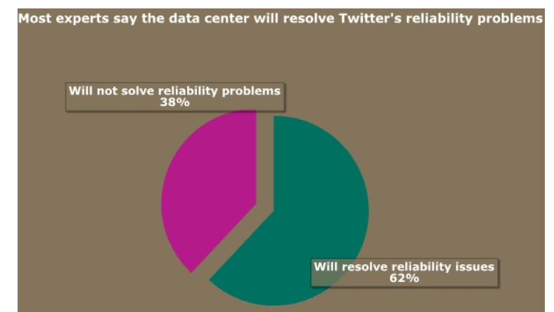
Percentages of the possibility of success in solving the reliability issues

Facebook is also having the reliability issues like Twitter have. According to an article which is owned by Samuel Gibbs, here are few examples for the Facebook outages in recent years.
- 27 January 2015

The latest 50-minute outage was caused by Facebook attempting to change something within its systems which went wrong. The outage hit both the site and apps, but impacted other services including Instagram, Tinder, AOL messenger and Hipchat, which rely on Facebook for logins.
- 1 August 2014

Facebook’s second outage in two months was caused by another server error, which again affected Facebook’s site, apps and sites and services that use its login system.

- 19 June 2014

June was a big deal for Facebook – its longest outage in four years, which saw the site down for 31 minutes and was the start of an increasing frequency of site issues. Both the website and Facebook smartphone and tablet apps were affected, leading users to seek refuge on other social networks including Twitter and even Google+.
- 21 October 2013

Facebook’s engineers were to blame for another site issue, this time not an outage but a “read-only error”, which prevented users from posting status updates for more than four hours. The rest of the site was functional, but caused problems for at least 3,587 other sites, according to data from IT management firm Compuware.
- 24 September 2010

In 2010, Facebook suffered a two-hour disruption that was apparently down to a fiendishly complex networking problem, again caused by its engineers.
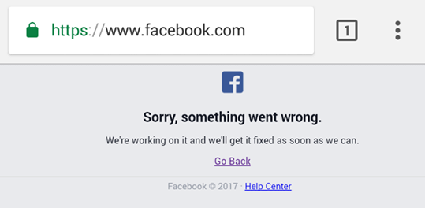

Facebook error message displayed for a user recently (2017)
Both Twitter and Facebook have their ups and downs over years and even now, reliability issues as mentioned above and both parties have taken actions to minimize the reliability issues. But since Facebook seemed having more reliability issues compared to Twitter like down times for a long time continuously year by year, we can prove that Twitter comes out more reliable than Facebook.

Conclusion

References

(History start)

[1] https://en.wikipedia.org/wiki/Twitter

[2] http://logos.wikia.com/wiki/Twitter

[3] https://blog.bufferapp.com/how-twitter-evolved-from-2006-to-2011

[4] https://prezi.com/lf6nwwz1tm-y/social-media/

[5] http://eprints.qut.edu.au/66321/1/Twitter_and_Society_%282014%29.pdf

[6] http://onlinelibrary.wiley.com/doi/10.1111/jcc4.12074/full

[7] http://media140.com/news/historyoftwitter

[8] https://twittercounter.com/pages/100

[9] https://rucreativebloggingfa13.files.wordpress.com/2013/09/completeguidetosocialmedia.pdf

[10] http://www.telegraph.co.uk/news/worldnews/europe/germany/4974916/Germany-school-shooting-Twitter-first-with-the-news-again.html

[11] http://snap.stanford.edu/soma2010/papers/soma2010_11.pdf

[12] https://en.wikipedia.org/wiki/Timeline_of_Twitter

[13] http://www.tandfonline.com/doi/full/10.1080/21670811.2013.808456?src=recsys&

(History end)

[1] Hashemi, Mazdak. "The Infrastructure Behind Twitter: Efficiency And Optimization | Twitter Blogs". Blog.twitter.com. N.p., 2017. Web. 10 May 2017.
[2] Neppelenbroek, Matthijs. Twitter. An Architectural Review. 1st ed. 2011. Web. 10 May 2017.
[1] http://guardianlv.com/2013/11/twitter-top-5-reasons-its-more-reliable-than-facebook/
[2] http://investorplace.com/2013/11/fb-vs-twtr-facebook-twitter-reliable/#.WRKxmNKGNPZ
[3] http://business.time.com/2013/11/06/how-twitter-slayed-the-fail-whale/
[4] https://twitter.com/search?q=%23FAILWHALE
[5] http://www.businessinsider.com/twitter-destroys-facebook-2010-12
[6] https://www.theguardian.com/technology/2015/jan/27/is-facebook-down-outages
[7] https://www.theguardian.com/technology/2014/jun/19/facebook-unavailable-longest-outage-four-years
[8] http://wave.wavemetrix.com/content/twitter-s-long-overdue-data-centre-solve-reliability-problems-00135

Appendices

